Spring Boot

1. It’s a module of spring from which we can speed up the development
2. In how many ways we can configure a spring boot project?
   * 3 ways
   * Configure in STS (by spring.org)
   * Configure in Eclipse
   * Use Spring boot CLI

Create a Spring Boot Application:

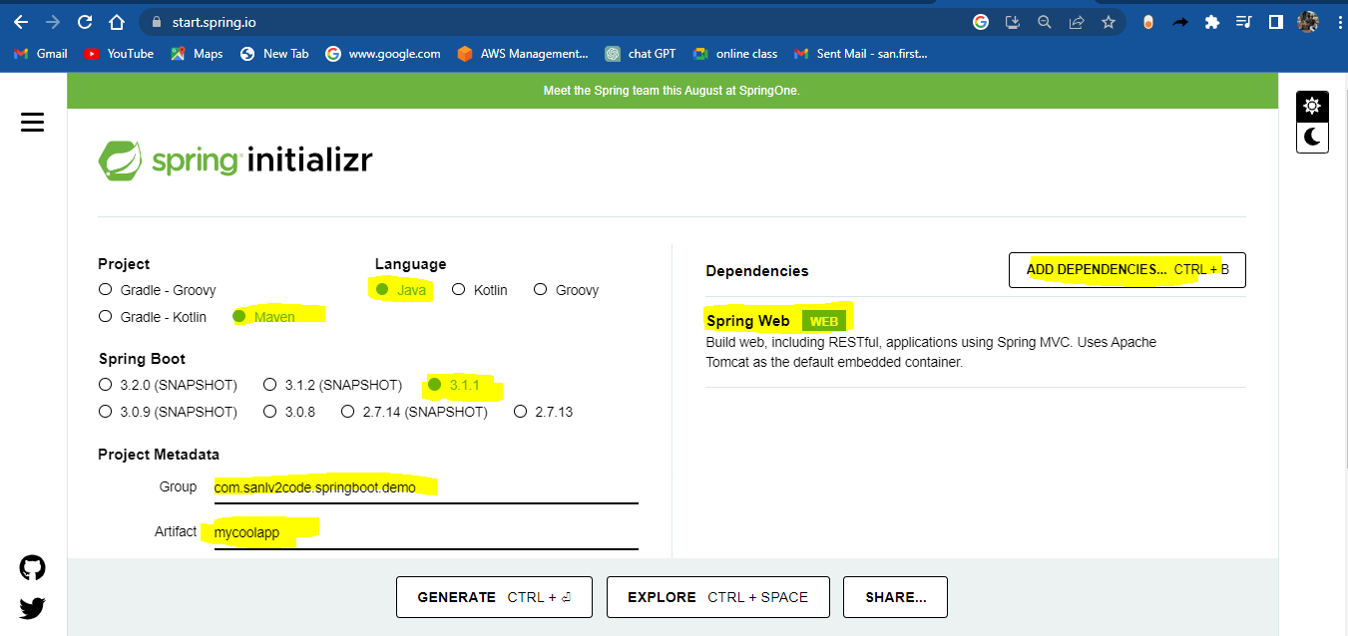

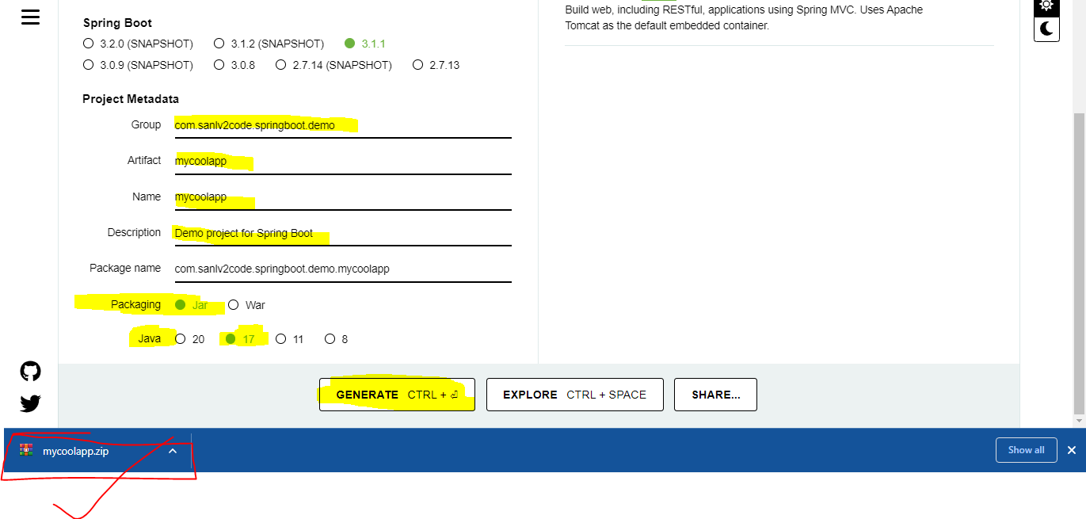

Unzip the .zip file and store in any drive location of your choice.

In your STS or Eclipse load the project and your project is ready to code.

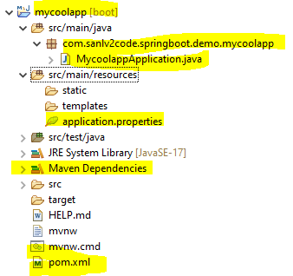

**NOTE**: For better configuration, if you are using Spring Boot 3.x or above version, it’s recommended to use Java 17 or above version.

Try to execute the application using ‘Java Application’.

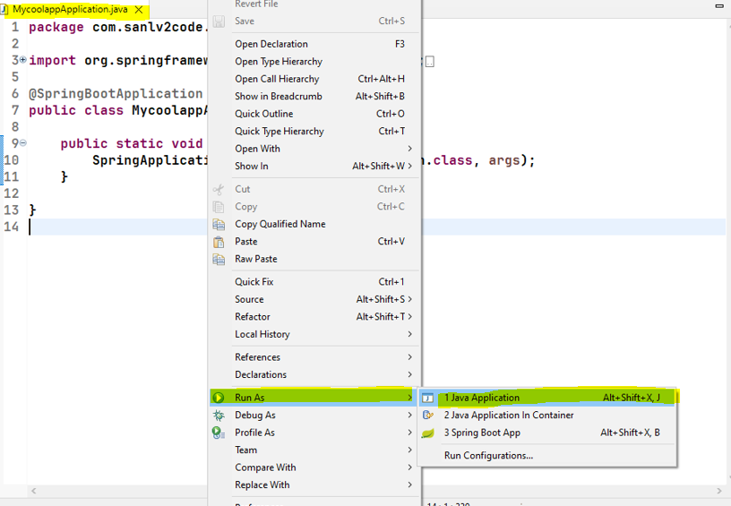

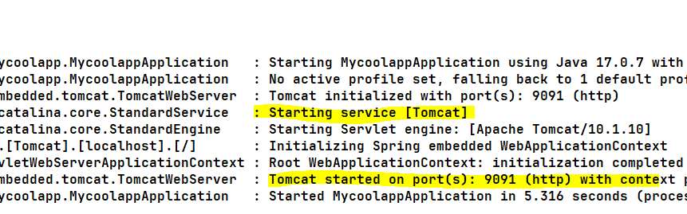

While checking the application in browser with the server port number 9091( in your case it can be 8080), you may end up with the following error screen in browser:

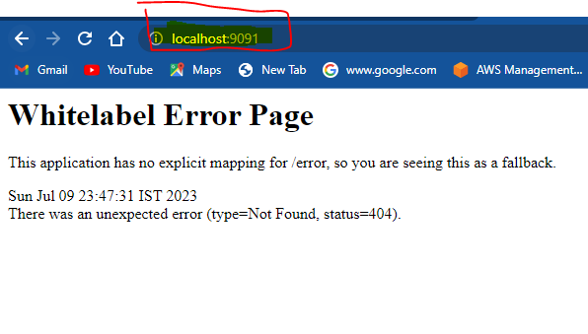

Create a new package and write a ‘RestController’ class to solve the above error:

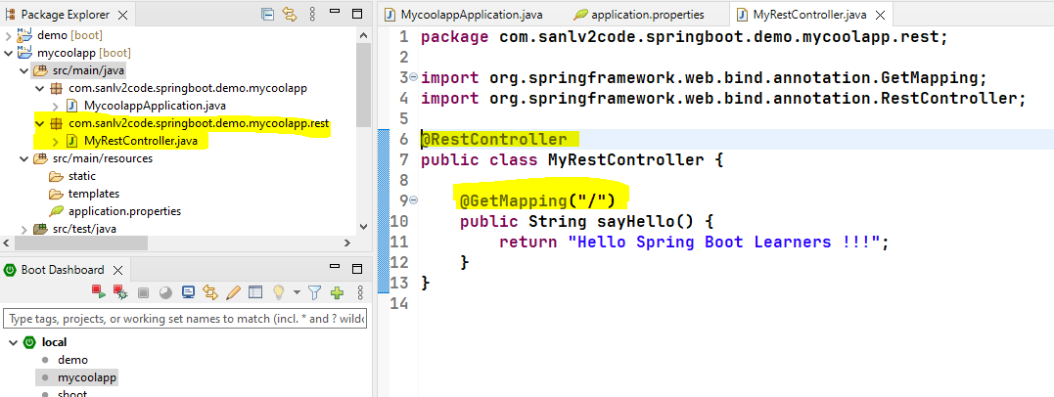

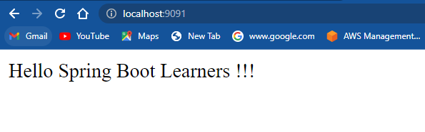

Spring Boot Crud Applications using Thymeleaf:

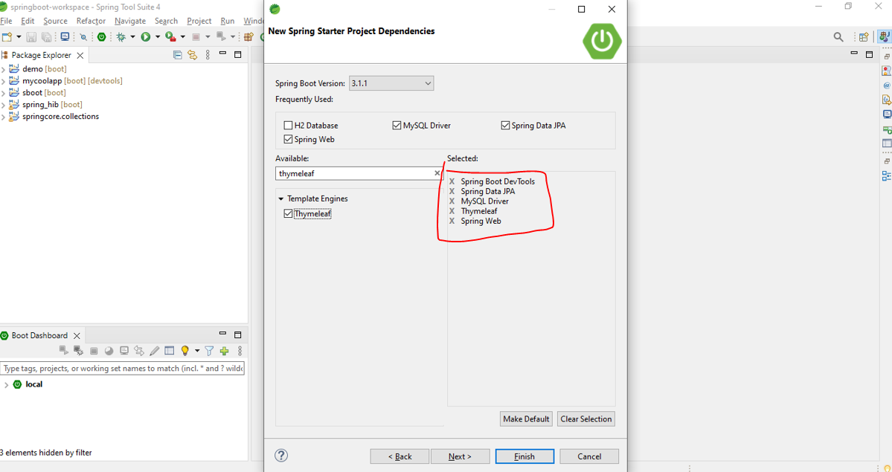

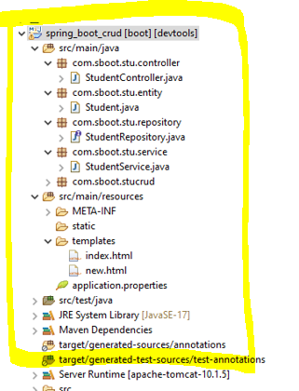

**package com.sboot.stu.entity;**

**import jakarta.persistence.Entity;**

**import jakarta.persistence.GeneratedValue;**

**import jakarta.persistence.GenerationType;**

**import jakarta.persistence.Id;**

**@Entity**

**public class Student {**

**@Id**

**@GeneratedValue(strategy = GenerationType.*IDENTITY*)**

**private Long id;**

**private String studentname;**

**private String course;**

**private int fee;**

**public Student() {**

**}**

**public Student(Long id, String studentname, String course, int fee) {**

**this.id = id;**

**this.studentname = studentname;**

**this.course = course;**

**this.fee = fee;**

**}**

**public Long getId() {**

**return id;**

**}**

**public void setId(Long id) {**

**this.id = id;**

**}**

**public String getStudentname() {**

**return studentname;**

**}**

**public void setStudentname(String studentname) {**

**this.studentname = studentname;**

**}**

**public String getCourse() {**

**return course;**

**}**

**public void setCourse(String course) {**

**this.course = course;**

**}**

**public int getFee() {**

**return fee;**

**}**

**public void setFee(int fee) {**

**this.fee = fee;**

**}**

**}**

**package com.sboot.stu.repository;**

**import org.springframework.data.jpa.repository.JpaRepository;**

**import org.springframework.stereotype.Repository;**

**import com.sboot.stu.entity.Student;**

**@Repository**

**public interface StudentRepository extends JpaRepository<Student, Long> {**

**}**

**package com.sboot.stu.controller;**

**import java.util.List;**

**import org.springframework.beans.factory.annotation.Autowired;**

**import org.springframework.stereotype.Controller;**

**import org.springframework.ui.Model;**

**import org.springframework.web.bind.annotation.GetMapping;**

**import org.springframework.web.bind.annotation.ModelAttribute;**

**import org.springframework.web.bind.annotation.PathVariable;**

**import org.springframework.web.bind.annotation.RequestMapping;**

**import org.springframework.web.bind.annotation.RequestMethod;**

**import org.springframework.web.servlet.ModelAndView;**

**import com.sboot.stu.entity.Student;**

**import com.sboot.stu.service.StudentService;**

**@Controller**

**public class StudentController {**

**@Autowired**

**private StudentService service;**

**@GetMapping("/")**

**public String viewHomePage(Model model) {**

**List<Student> liststudent = service.listAll();**

**model.addAttribute("liststudent", liststudent);**

**System.*out*.print("Get / ");**

**return "index";**

**}**

**@GetMapping("/new")**

**public String add(Model model) {**

**model.addAttribute("student", new Student());**

**return "new";**

**}**

**@RequestMapping(value = "/save", method = RequestMethod.*POST*)**

**public String saveStudent(@ModelAttribute("student") Student std) {**

**service.save(std);**

**return "redirect:/";**

**}**

**@RequestMapping("/edit/{id}")**

**public ModelAndView showEditStudentPage(@PathVariable(name = "id") int id) {**

**ModelAndView mav = new ModelAndView("new");**

**Student std = service.get(id);**

**mav.addObject("student", std);**

**return mav;**

**}**

**@RequestMapping("/delete/{id}")**

**public String deletestudent(@PathVariable(name = "id") int id) {**

**service.delete(id);**

**return "redirect:/";**

**}**

**}**

**package com.sboot.stu.service;**

**import java.util.List;**

**import org.springframework.beans.factory.annotation.Autowired;**

**import org.springframework.stereotype.Service;**

**import com.sboot.stu.entity.Student;**

**import com.sboot.stu.repository.StudentRepository;**

**@Service**

**public class StudentService {**

**@Autowired**

**private StudentRepository repo;**

**public List<Student> listAll() {**

**return repo.findAll();**

**}**

**public void save(Student std) {**

**repo.save(std);**

**}**

**public Student get(long id) {**

**return repo.findById(id).get();**

**}**

**public void delete(long id) {**

**repo.deleteById(id);**

**}**

**}**

**<!DOCTYPE html>**

**<html xmlns="http://www.w3.org/1999/xhtml" xmlns:th="http://www.thymeleaf.org">**

**<head>**

**<link rel="stylesheet" href="https://stackpath.bootstrapcdn.com/bootswatch/4.5.2/cosmo/bootstrap.min.css" />**

**<script src="https://stackpath.bootstrapcdn.com/bootstrap/4.5.2/js/bootstrap.min.js"></script>**

**</head>**

**<body>**

**<div>**

**<h2>Spring Boot Crud System -Student Registation</h2>**

**<tr>**

**<div align="left">**

**<h3><a th:href="@{'/new'}">Add new</a></h3>**

**</div>**

**</tr>**

**<tr>**

**<div class="col-sm-5" align="center">**

**<div class="panel-body" align="center">**

**<table class="table">**

**<thead class="thead-dark">**

**<tr>**

**<th>Student ID</th>**

**<th>Student Name</th>**

**<th>Course</th>**

**<th>Fee</th>**

**<th>Edit</th>**

**<th>Delete</th>**

**</tr>**

**</thead>**

**<tbody>**

**<tr th:each="student : ${liststudent }">**

**<td th:text="${student.id}">Student ID</td>**

**<td th:text="${student.studentname}">StudentName</td>**

**<td th:text="${student.course}">Course</td>**

**<td th:text="${student.fee}">Fee</td>**

**<td>**

**<a th:href="@{'/edit/' + ${student.id}}">Edit</a>**

**</td>**

**<td>**

**<a th:href="@{'/delete/' + ${student.id}}">Delete</a>**

**</td>**

**</tr>**

**</tbody>**

**</table>**

**</div>**

**</div>**

**</tr>**

**</tbody>**

**</table>**

**<div>**

**</body>**

**</html>**

**<!DOCTYPE html>**

**<html xmlns="http://www.w3.org/1999/xhtml" xmlns:th="http://www.thymeleaf.org">**

**<head>**

**<meta charset="utf-8" />**

**<title>Create New Product</title>**

**<link rel="stylesheet" href="https://stackpath.bootstrapcdn.com/bootswatch/4.5.2/cosmo/bootstrap.min.css" />**

**<script src="https://stackpath.bootstrapcdn.com/bootstrap/4.5.2/js/bootstrap.min.js"></script>**

**</head>**

**<body>**

**<div align="center">**

**<h1>Create New Student</h1>**

**<br />**

**<div class="col-sm-4">**

**<form action="#" th:action="@{/save}" th:object="${student}" method="post">**

**<div alight="left">**

**<tr>**

**<label class="form-label">Student Name</label>**

**<td>**

**<input type="hidden" th:field="*{id}" />**

**<input type="text" th:field="*{studentname}" class="form-control"**

**placeholder="Student Name" />**

**</td>**

**</tr>**

**</div>**

**<div alight="left">**

**<tr>**

**<label class="form-label">Course</label>**

**<td><input type="text" th:field="*{course}" class="form-control" placeholder="Course" /></td>**

**</tr>**

**</div>**

**<div alight="left">**

**<tr>**

**<label class="form-label">Fee</label>**

**<td><input type="text" th:field="*{fee}" class="form-control" placeholder="Fee" /></td>**

**</tr>**

**</div>**

**<br>**

**<tr>**

**<td colspan="2"><button type="submit" class="btn btn-info">Save</button> </td>**

**</tr>**

**</table>**

**</form>**

**</div>**

**</body>**

**</html>**